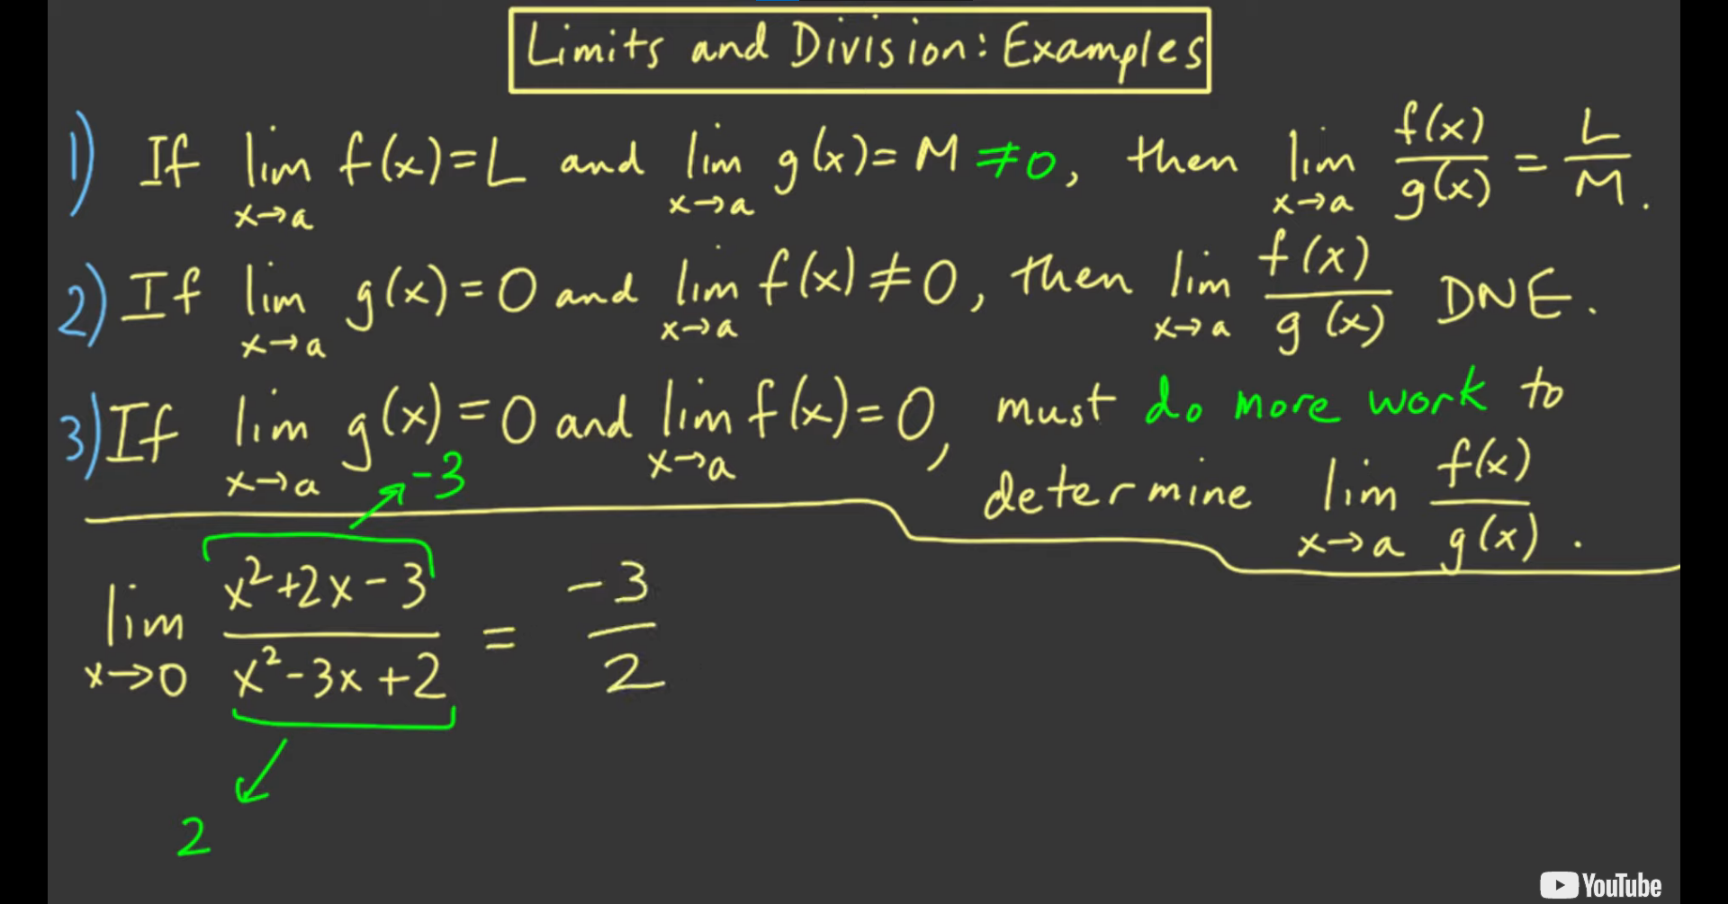

* 1st case example

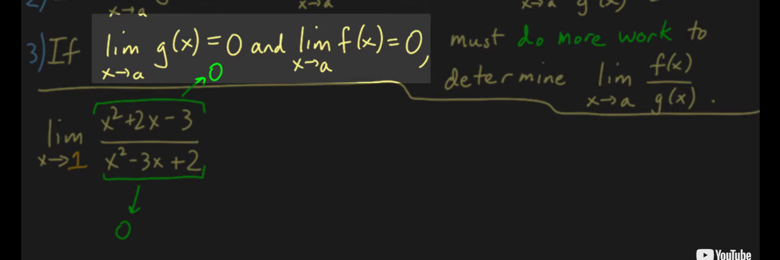

* 3rd case example

Doing more work when both equal to 0

For polynomials

* Do factorization

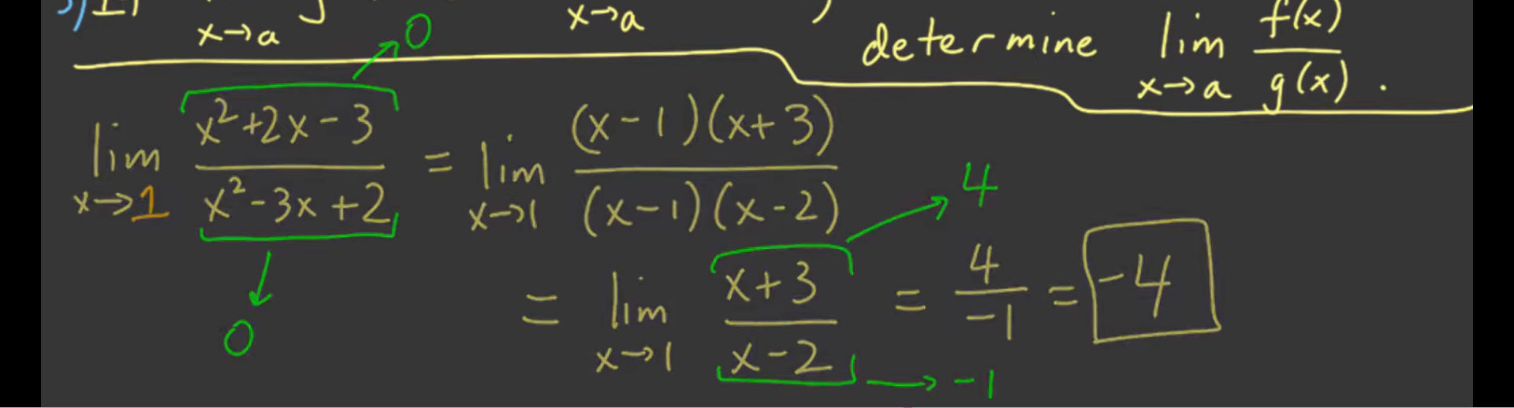

* + This falls on the first law

Another example:

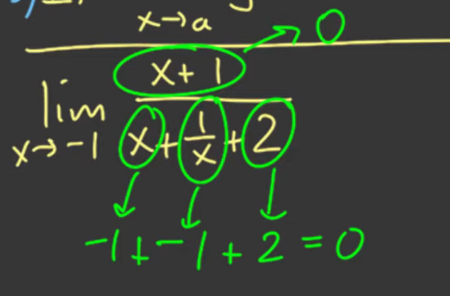

* + Clean up first

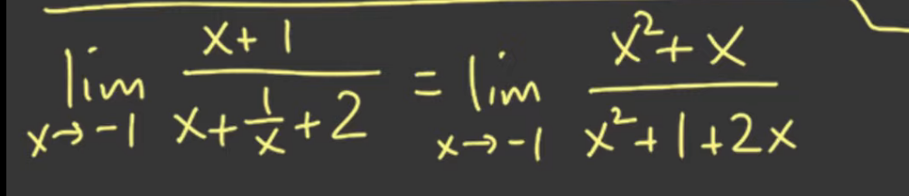

* + Then factor

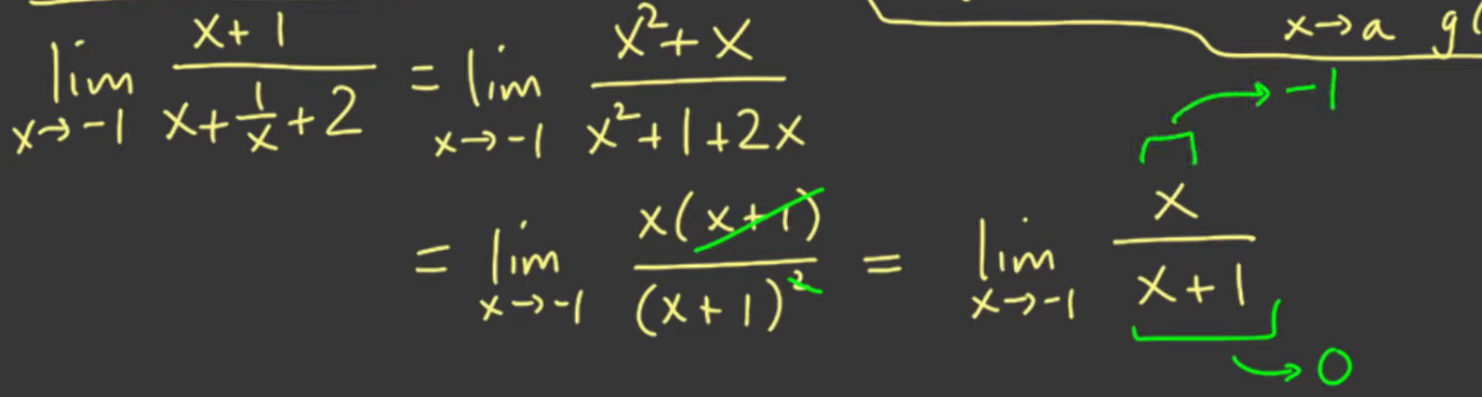

* + This falls on the second law thus DNE



